**How to Invoice a Student**

1. Select the File menu at the top of the Home Display Screen
2. File -> Student Scheduling

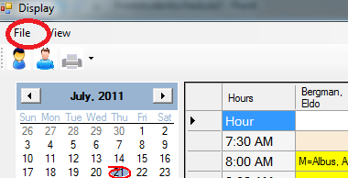

1. The Login Dialog will appear

Select the down arrow to the right of the drop down dialog box to display the names of the clinicians to choose from.

Choose a clinician name.

Click [**Sign-in**]

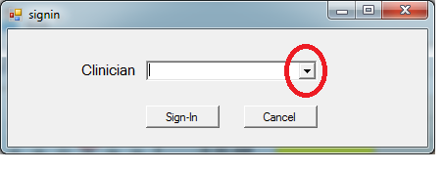

1. Select the days that will be invoiced

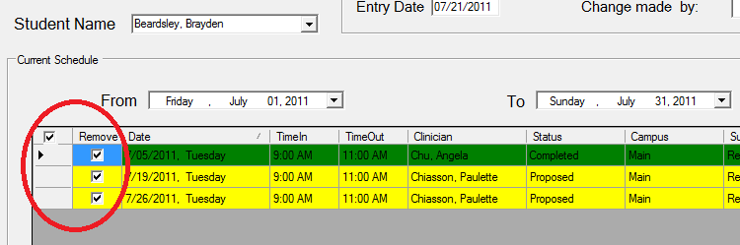

1. Select the [**Invoice**] button

